1. Perform basic image handling and processing operations on an image. Read an image using Python and convert the image into Gray-scale.

Output:
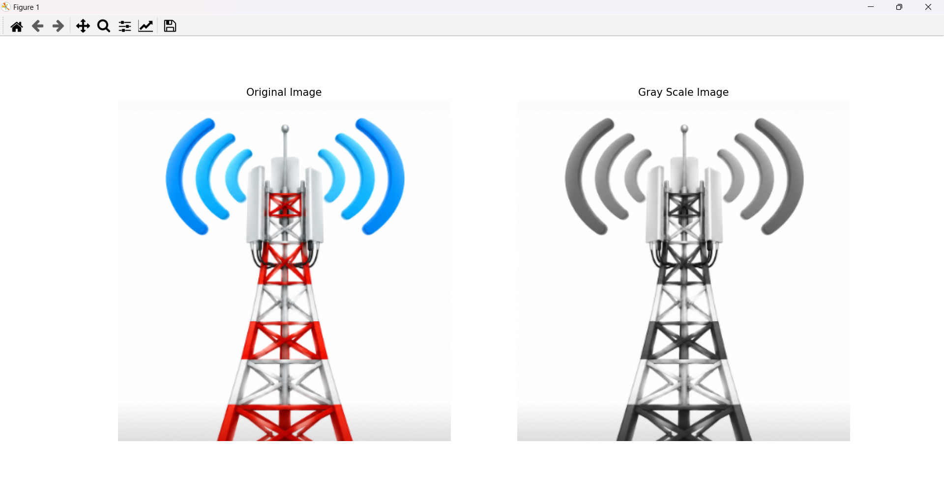
2. Perform basic image handling and processing operations on an image. Read an image using Python and convert the image into Blur using Gaussian Blur.

Output:
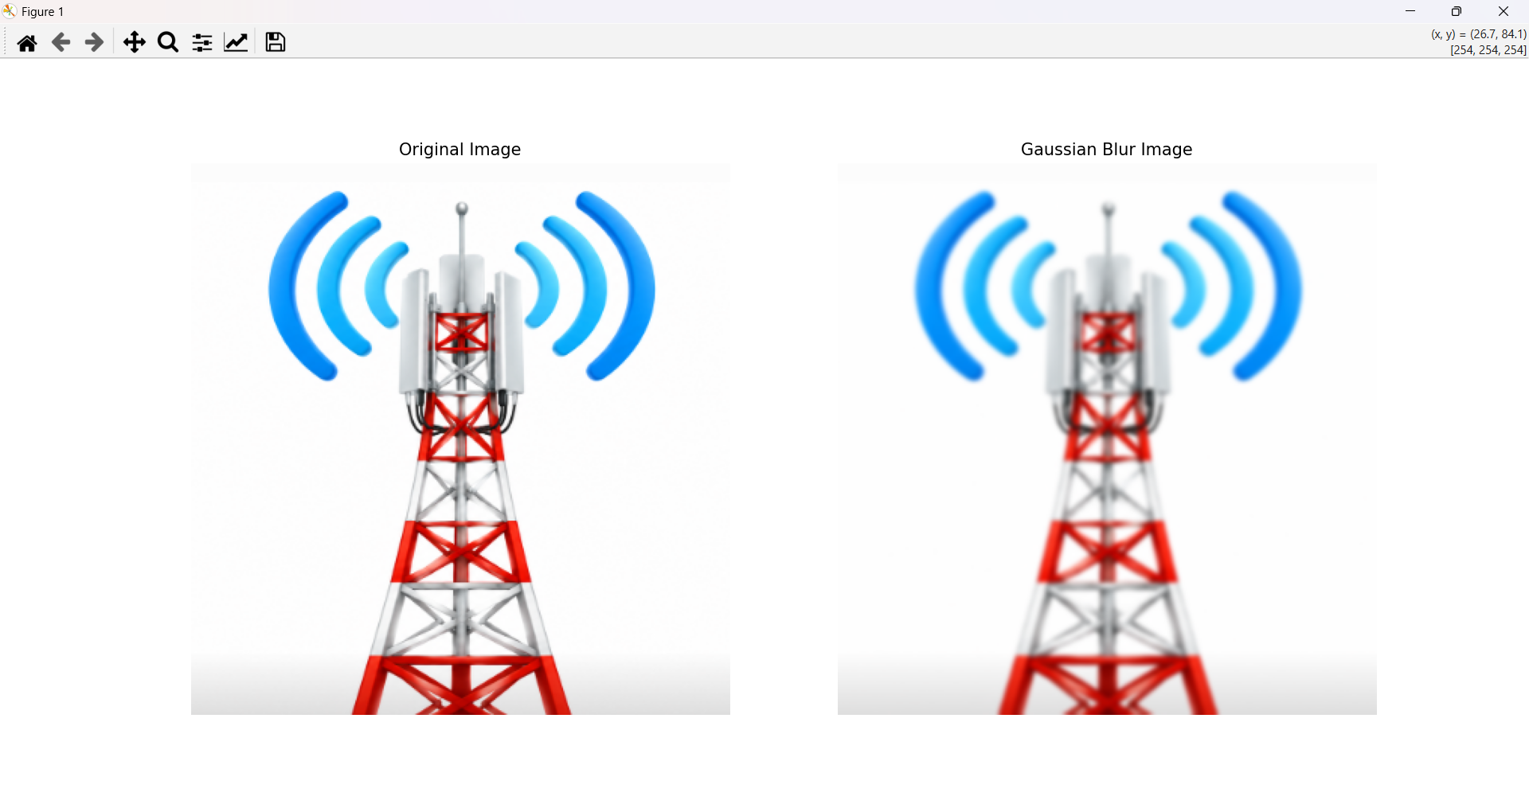

4.Perform basic image handling and processing operations on an image. Read an image using Python and display image outline using Canny function.
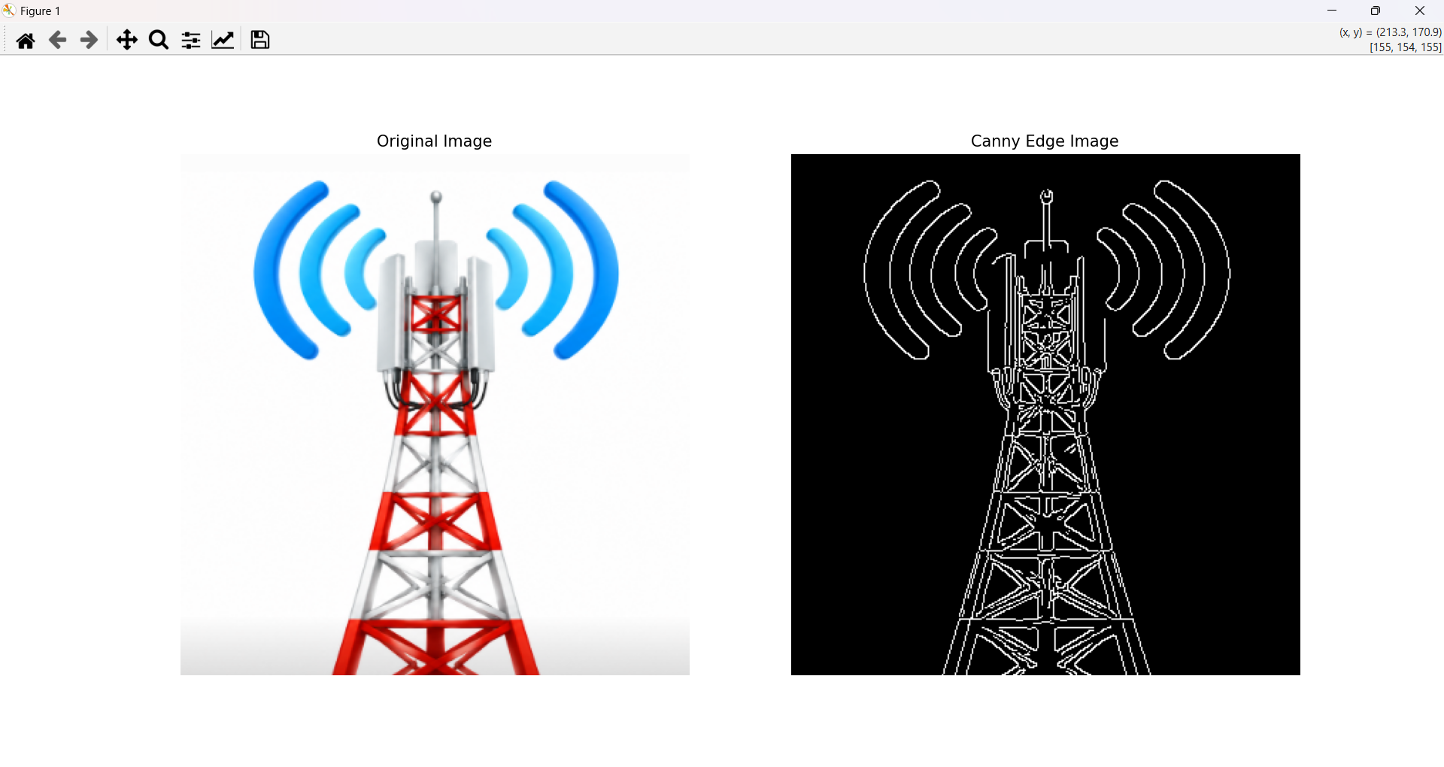
5. Write a Python function to analyze the histogram of the given input image based on color levels using OpenCV.
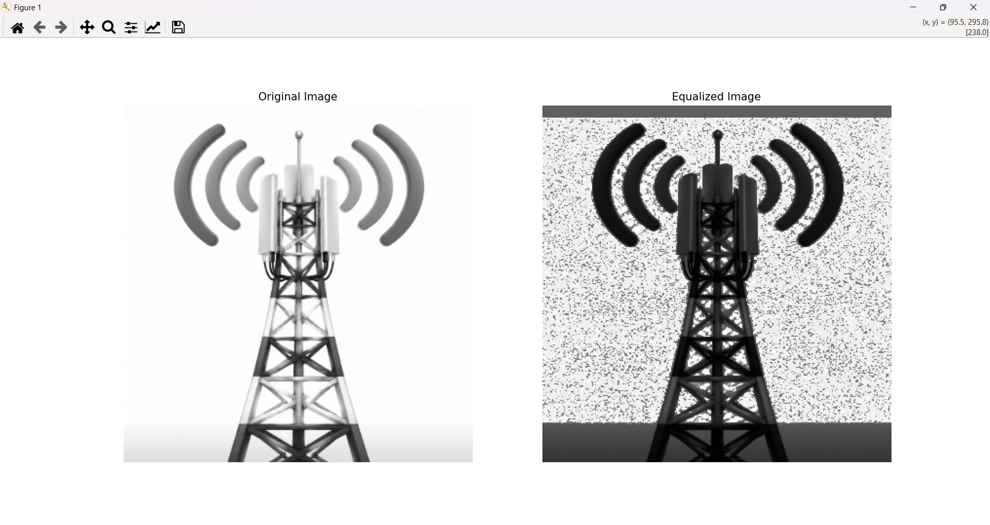
6. Perform basic image processing operation and convert the image into eroded image using Erode function.
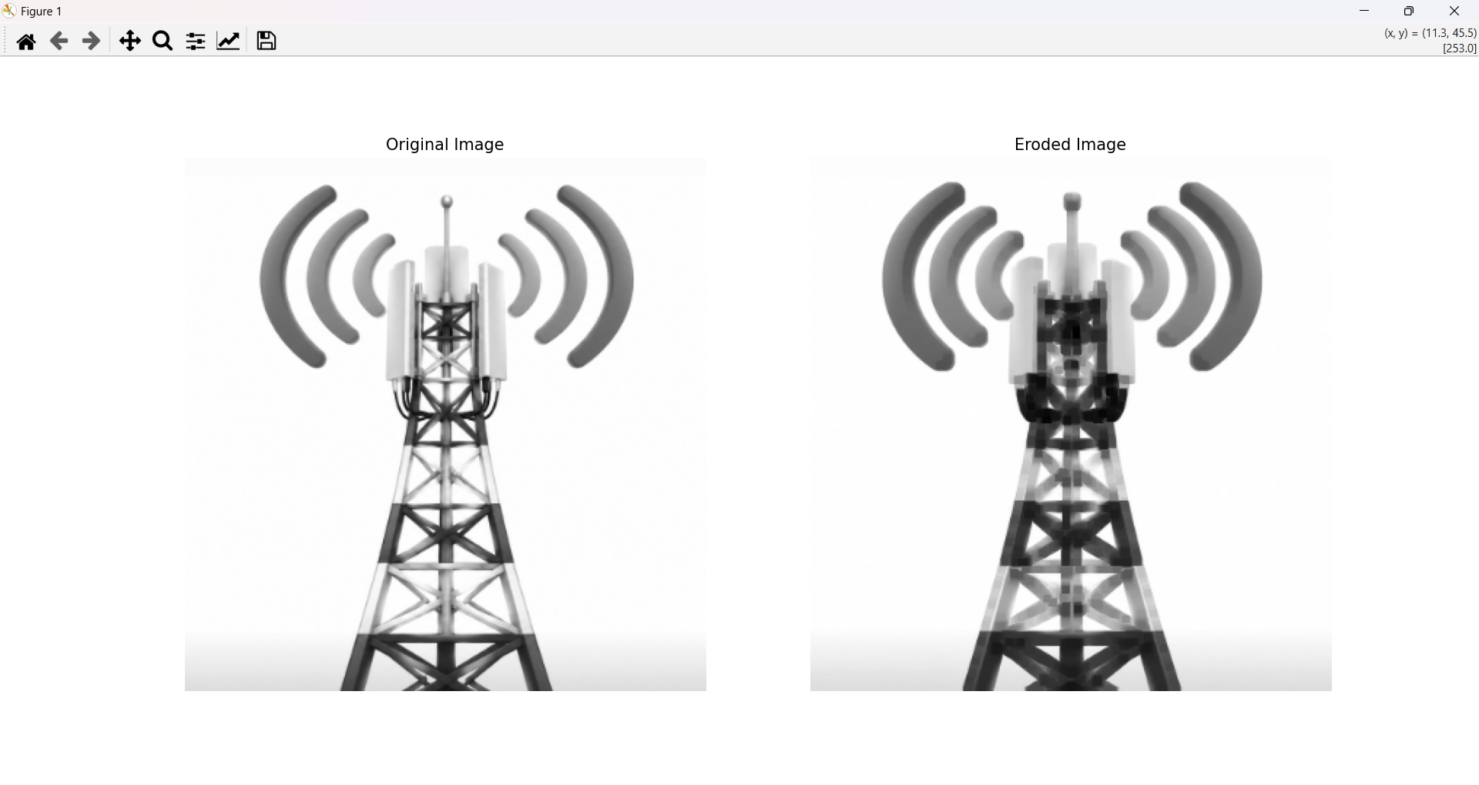
7. Perform basic video processing operations on captured video. Read video using Python and display in slow motion and fast motion.
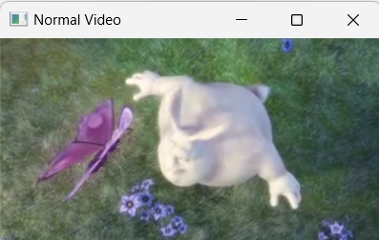

8. Perform basic image processing operation and dilate an image using Dilate function.

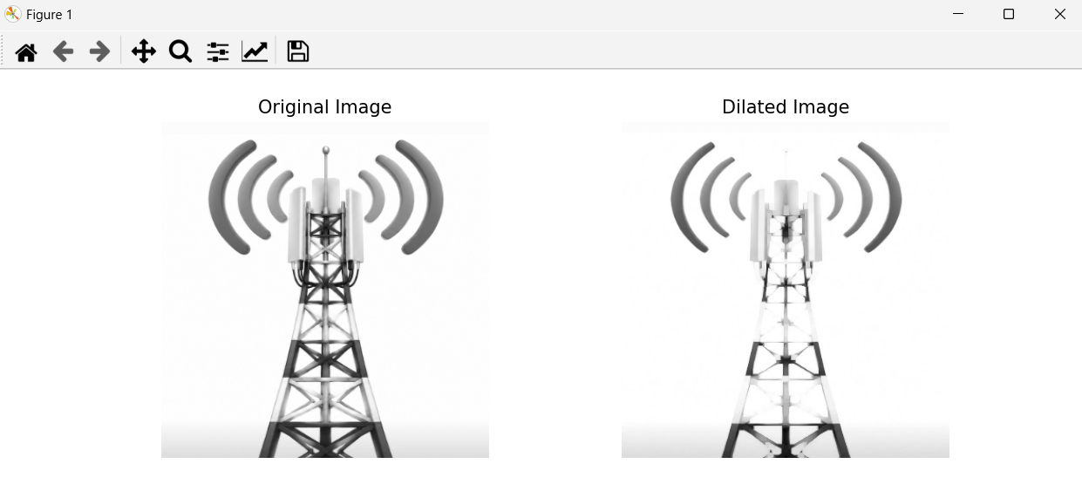
9. Image Scaling Techniques for Increasing and Decreasing Image Size using OpenCV

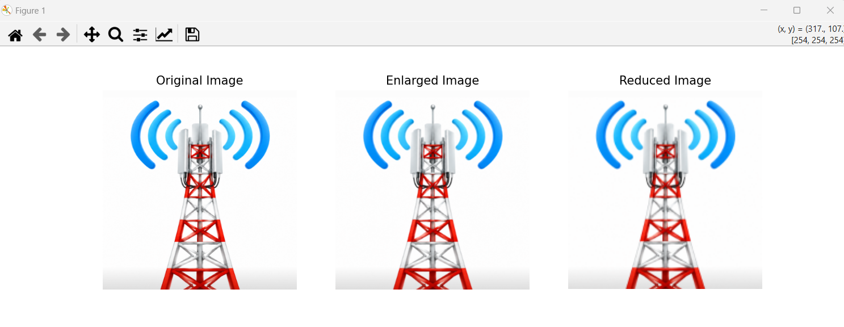
10. 90-Degree Clockwise Rotation of Image using OpenCV

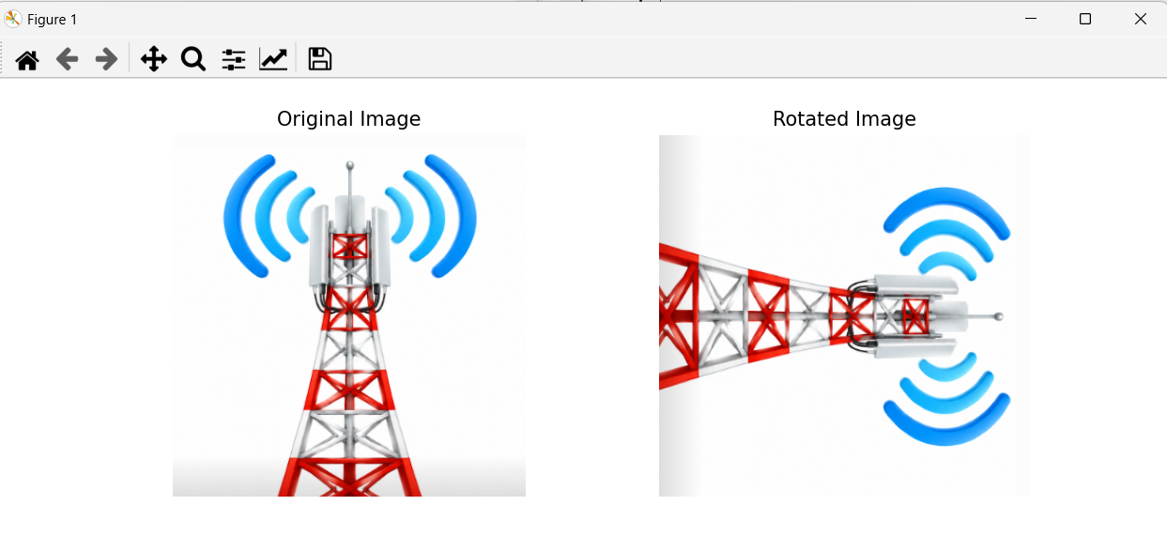
11. 180-Degree Clockwise Rotation of Image using OpenCV

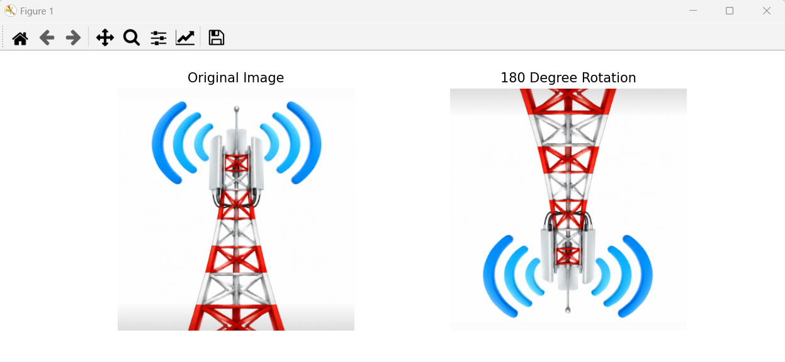
12. 270-Degree Clockwise Rotation of Image using OpenCV
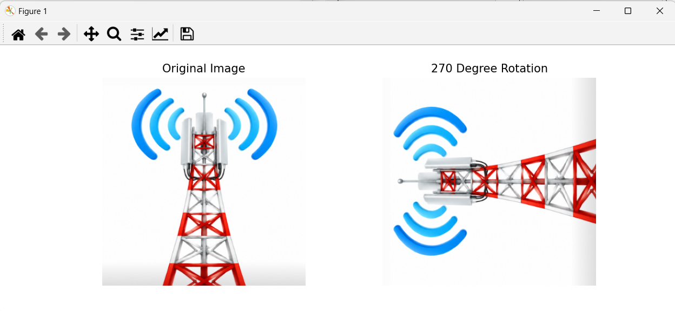

13. Affine Transformation of Image using Python and OpenCV
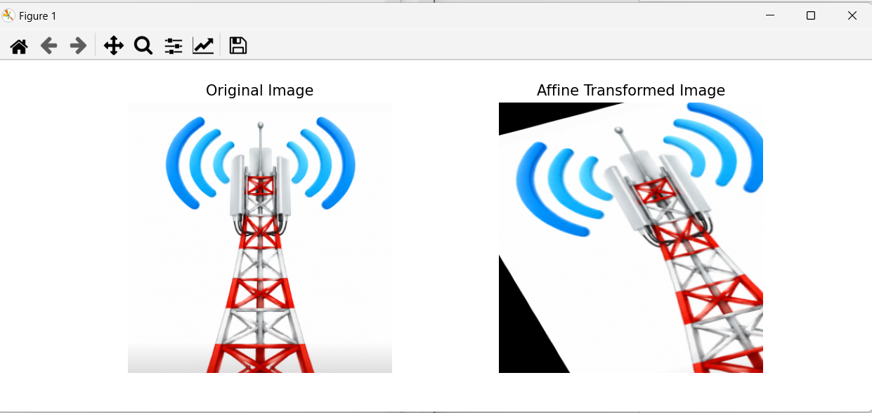
14. Perspective Transformation of Image using Python and OpenCV
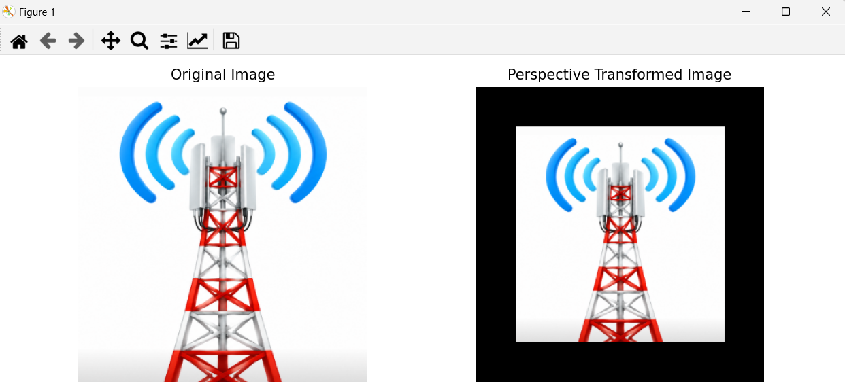
15. Corner Detection using Harris Corner Detection Algorithm
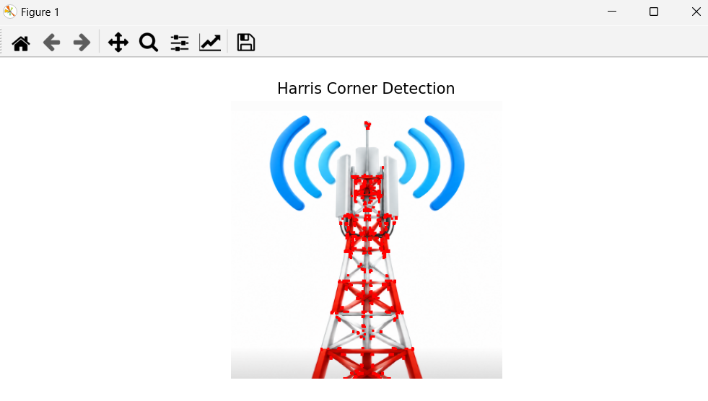
16. Implementation of Sobel Edge Detection Algorithm using OpenCV
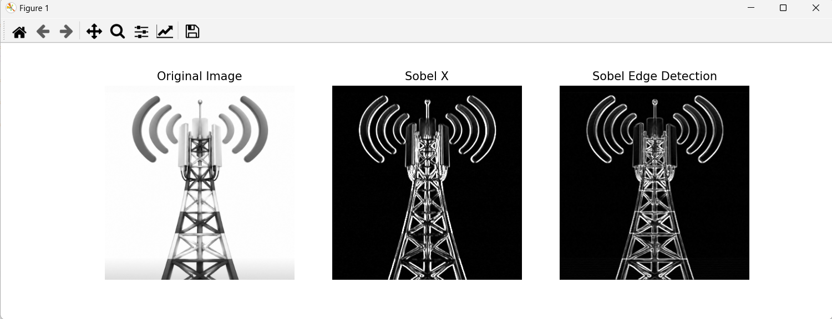
17. Implementation of Image Watermarking Technique using OpenCV
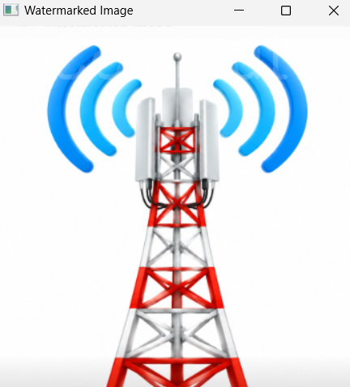
18. Image Cropping, Copying and Pasting using ROI in OpenCV
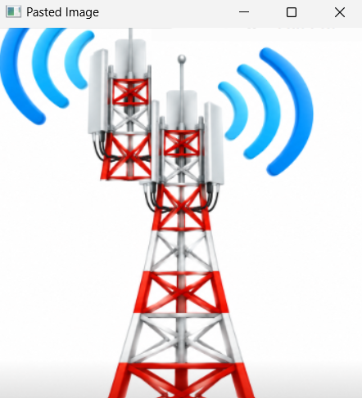
19. Implementation of Erosion Morphological Operation using OpenCV
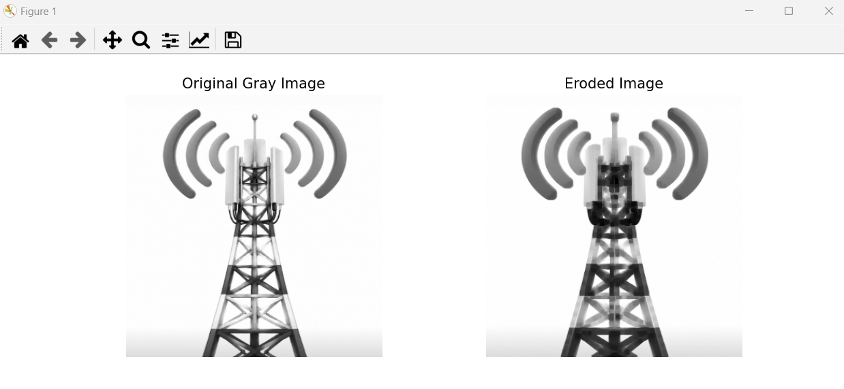
20. Implementation of Dilation Morphological Operation using OpenCV
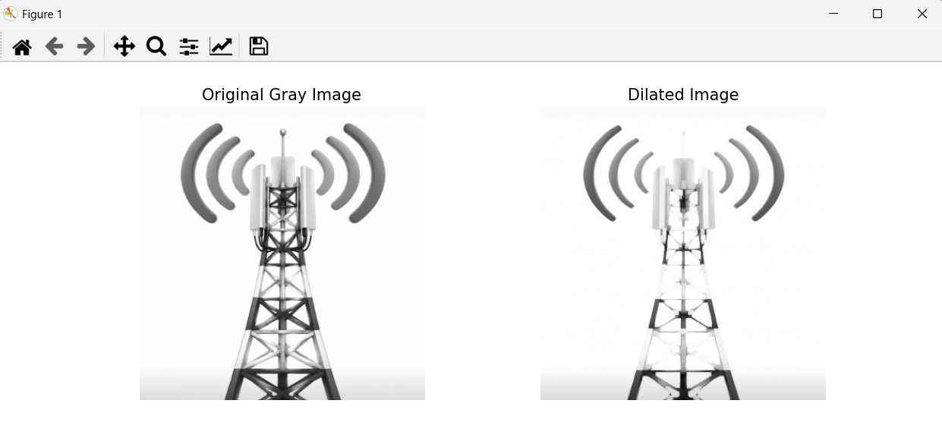
21. Implementation of Morphological Opening Operation using OpenCV
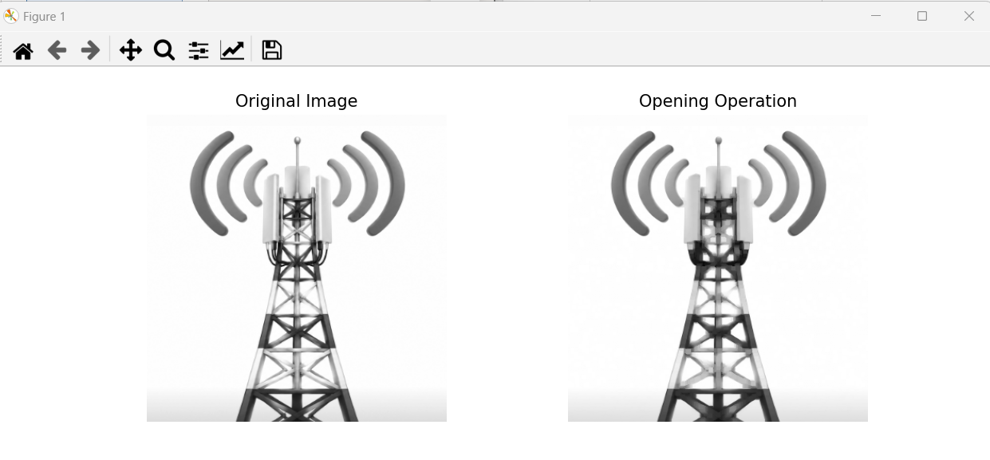
22. Implementation of Morphological Closing Operation using OpenCV
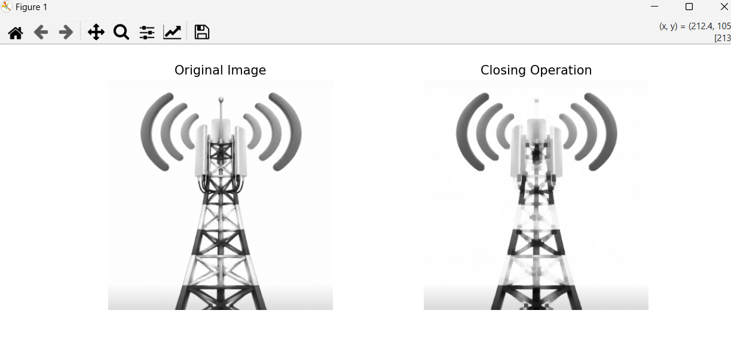
23. Implementation of Top Hat Morphological Operation using OpenCV
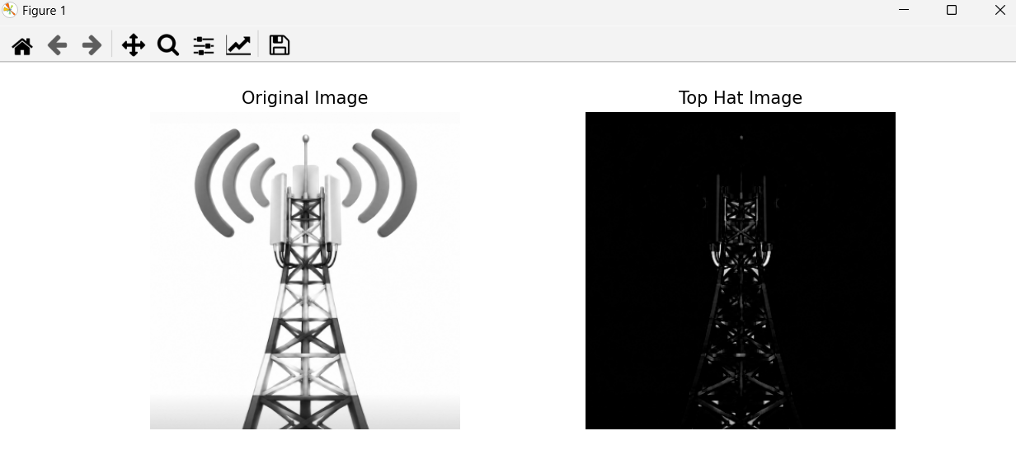
24. Implementation of Black Hat Morphological Operation using OpenCV
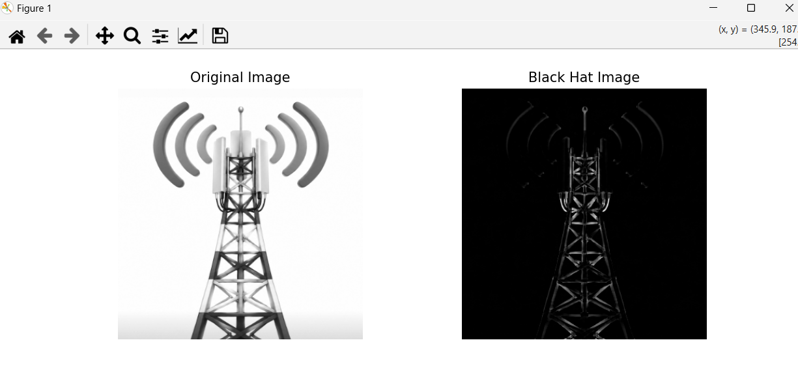
25. Object Recognition from Image using OpenCV
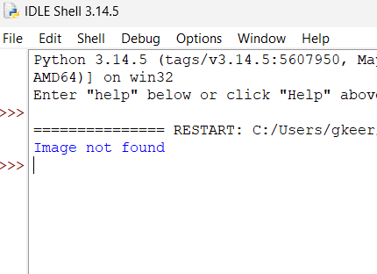

26. Implementation of Reverse Video Frames using OpenCV
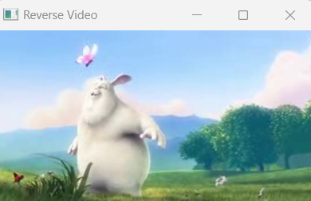
27. Implementation of Human Face Detection using OpenCV
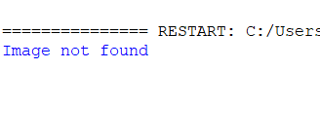
28. Implementation of Vehicle Detection in Video using OpenCV
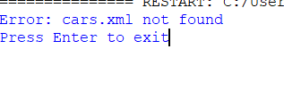
29. Implementation of Human Eye Detection using OpenCV
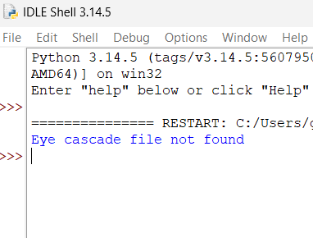
30. Implementation of Human Smile Detection using OpenCV
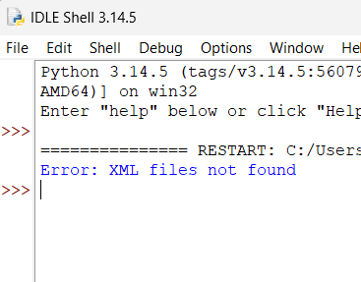

31. Implementation of Image Segmentation using Thresholding using OpenCV
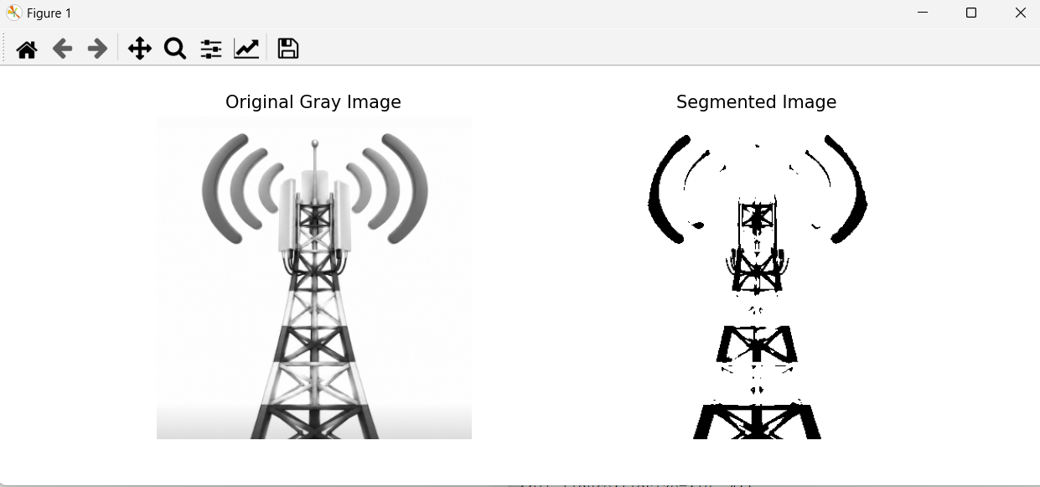

32. Creation of White Image with Four Colored Corner Boxes using OpenCV
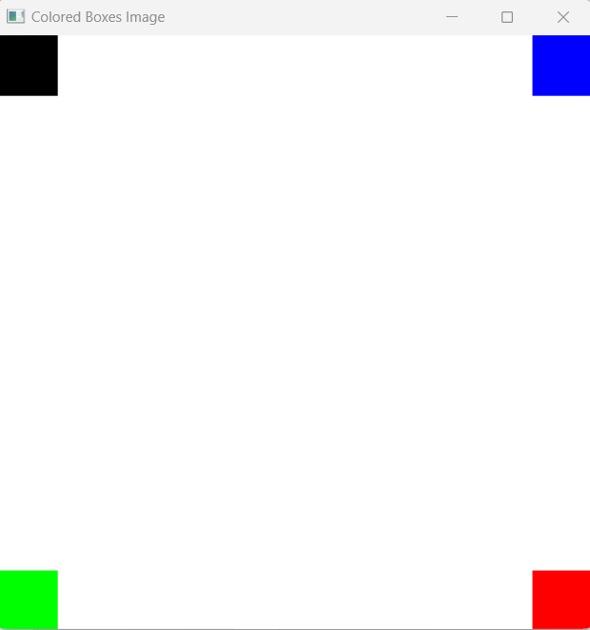

33. Creation of Rectangle Shape using OpenCV
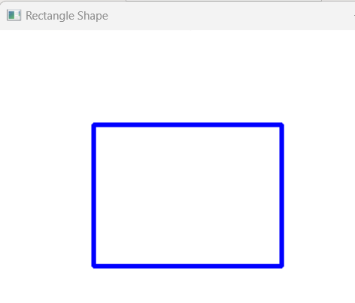
34. Creation of Circle Shape using OpenCV
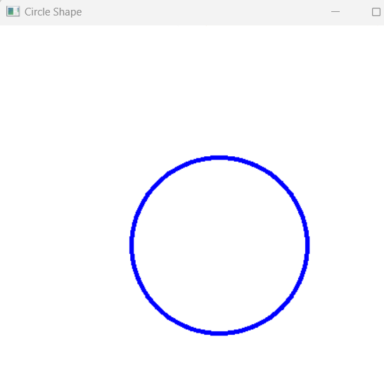
35. Display User Entered Text String on Image using OpenCV
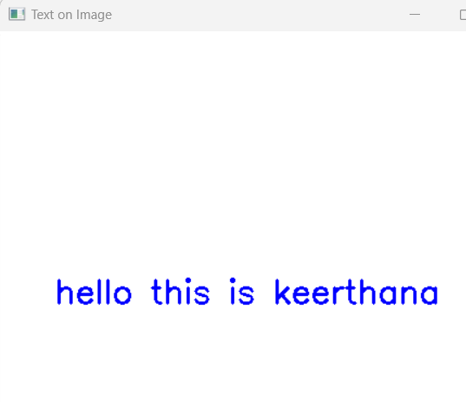
36. Background Subtraction based on Color Levels using OpenCV
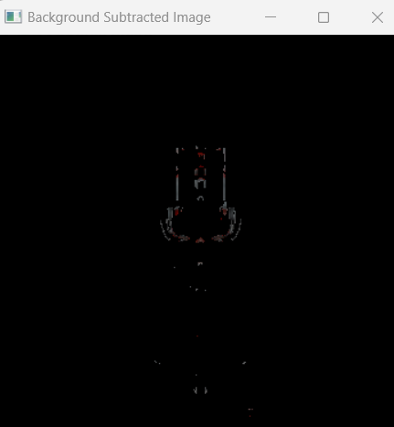

37. Foreground Subtraction based on Color Levels using OpenCV
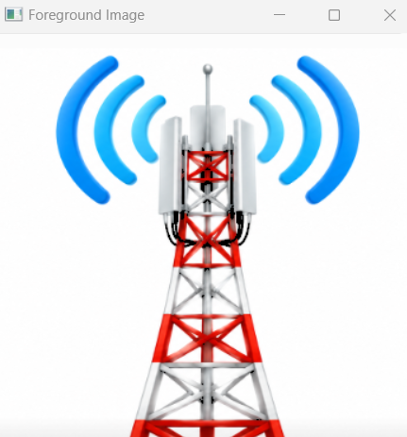

38. Count the Number of Faces in an Image using OpenCV
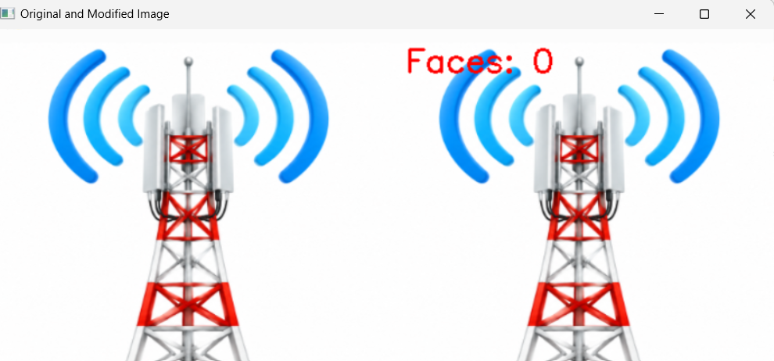

39. Play Video in Reverse Mode with Slow Motion using OpenCV
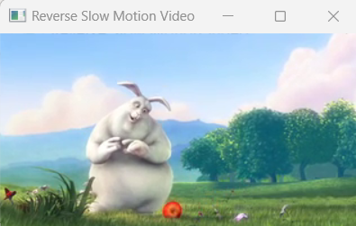
40. Extract Text from Videos using OpenCV
